# **Bot Commands: (brackets mean the parameter is optional)**

To call the bot, we need to send a command the bot recognizes starting with an exclamation mark. Initially, we will have only 3 commands to view, set, remove reminders.

**!SetReminder <date> <time> <name> [<ReminderDescription> <TypeOfReminder>]**

Example User Input: !SetReminder 27-04-21 1345 “COMP442 Exam” “Study Chapter 4” “Exam”  
Expected Bot Reply: Added “COMP442 Exam” reminder on 27-04-21 at 1345

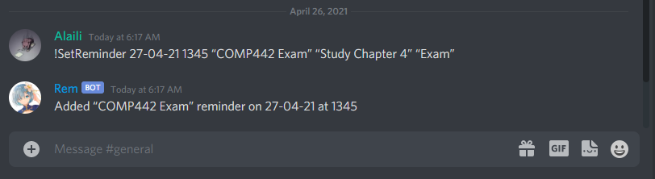

**!ViewReminder**

Example User Input: !ViewReminder  
Expected Bot Reply:

1. “COMP442 Exam” reminder on 27-04-21 at 1345  
2. “COMP462 Quiz” reminder on 30-04-21 at 0900  
3. “COMP512 Exam” reminder on 4-05-21 at 1630

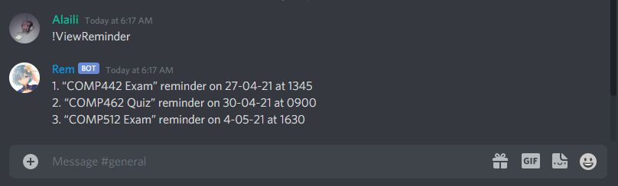

**Example of Reminder being set off:**



**!RemoveReminder**

Example User Input: !RemoveReminder  
Expected Bot Reply:

1. “COMP442 Exam” reminder on 27-04-21 at 1345  
2. “COMP462 Quiz” reminder on 30-04-21 at 0900  
3. “COMP512 Exam” reminder on 4-05-21 at 1630

Enter the number of the reminder to be deleted.

Expected User Input: 2  
Expected Bot Reply: Deleted “COMP462 Quiz” reminder

Expected User Input: !ViewReminder  
Expected Bot Reply:

1. “COMP442 Exam” reminder on 27-04-21 at 1345  
2. “COMP512 Exam” reminder on 4-05-21 at 1630

